# Chunky Trainers

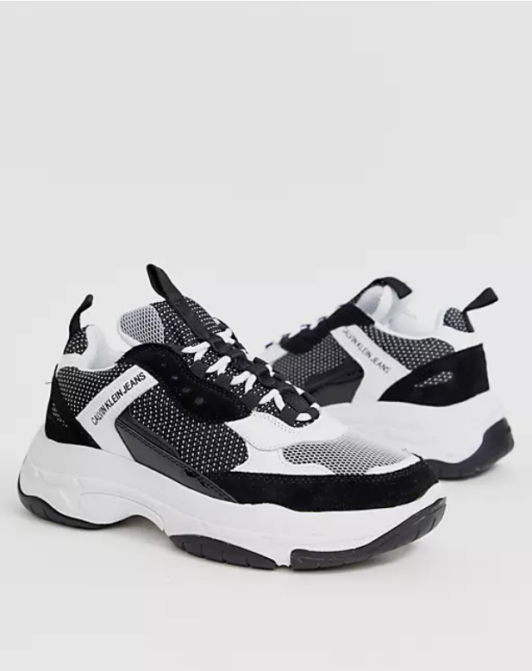 Product Details:

Color Combination: The CK Urbanite Chunky Trainers showcase a refined palette including charcoal black, warm grey, and light silver.

Material: Crafted from premium synthetic leather and breathable mesh materials, ensuring durability and comfort.

Sole: Features a chunky rubber sole with a sleek contrast color, providing both stability and style.

Closure: Secure lace-up closure system for a personalized and snug fit.

Branding: Subtle CK logo embossing on the tongue and side adds a touch of designer sophistication.

Comfort: Padded collar and cushioned insole offer exceptional comfort and support, making them perfect for all-day wear.

Style: The CK Urbanite Chunky Trainers effortlessly blend modern design with timeless elegance, making them suitable for various occasions.

Occasion: Ideal for casual outings, urban adventures, or adding a contemporary twist to everyday wear.

Versatility: Pair with jeans, joggers, or even casual shorts for a versatile and fashion-forward look that exudes confidence and style.